**Arduino – Analogue Piano Electronics**

**You will need:**

* Arduino Uno
* 1.5W Speakers
* 6 LEDs (Preferably of the same colour)
* 7 560Ω Resistors (Green, Blue, Yellow, Gold)
* 6 Push Switches
* 26 Jump Lead Wires

1

**First Steps**

To setup the piano, you will need a breadboard. A breadboard is used for connecting electronics without the need for soldering and allow for easy changing of components.

A breadboard works by connecting electronics in a specific way. This is explained below:

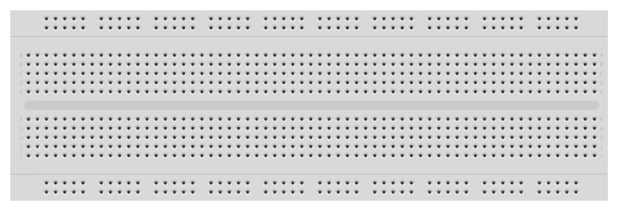

Anything connected in this vertical line will be connected to anywhere else in this line.

For example if a power cable is connected, the whole line receives power.

As with the horizontal lines, anything connected to any of the vertical line will be connected to those 5 holes in that line

Firstly, we need to connect a power supply to the breadboard so that our components can function. Make sure that the Arduino is powered via an appropriate power supply, e.g. Computer or Mains.

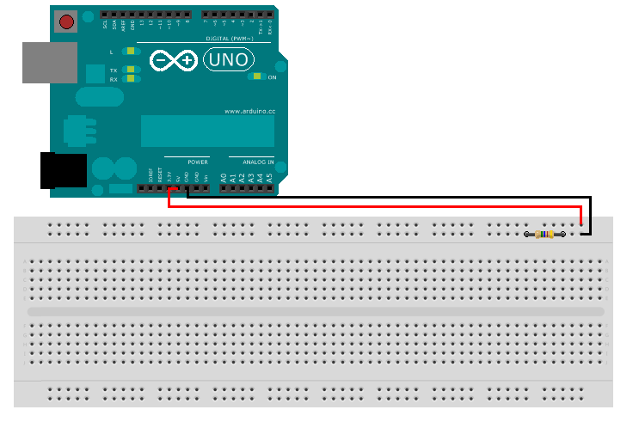

Connect one jump lead wire to the 5V slot on the Arduino and to a horizontal line on the breadboard. This will be the positive terminal of the circuit.

Connect another wire to the GND slot on the Arduino and to the other horizontal line on the breadboard. This will be the negative terminal of the circuit. Also insert a resistor on the horizontal line with the GND wire to resist any leftover current.

2

**Building the first sensor**

Now that we have power to connect our circuit, we can start constructing our first sensor that the Arduino will use to play notes.

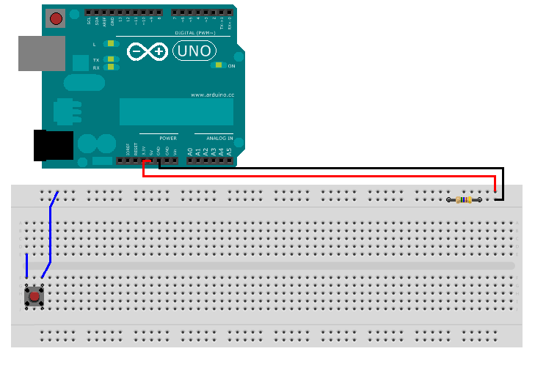

Connect two jump lead wires as shown above then insert a push switch so that it is connected to both wires.

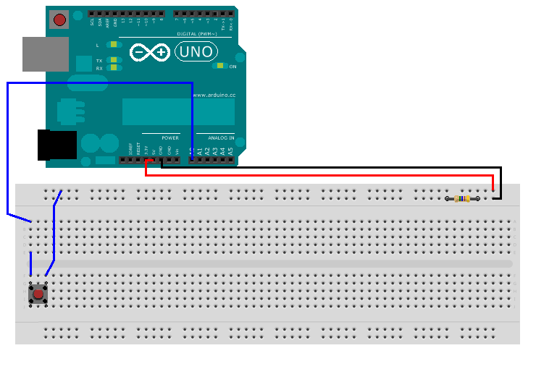

Next, connect a wire into the A0 input and to where it is connected shown above. This is the first sensor that the Arduino will detect due to being the first analogue input.

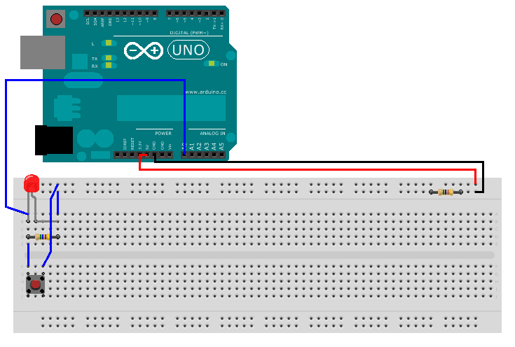

Insert a LED and Resistor as shown above and then connect a wire in the same vertical line as where the negative parts of the components are and to the negative horizontal wire.

At this point, you should have created your first sensor. You can test your sensor by pressing the button and seeing if the LED lights up.

**If the LED doesn’t light up:**

* **Check that your circuit matches the image above**
* **LED might be inserted the wrong way. Longer side is positive, shorter side is negative. Or LED could be broken.**
* **Resistors usually have a gold ring end. This must be connected on the negative side of the circuit.**

**Building the rest of the sensors**

3

Once you have completed your first sensor, the rest of the sensors are easy to construct since it follows the same layout as the first sensor. The only difference is that the other sensors are in a different position and is connect to different analogue inputs.

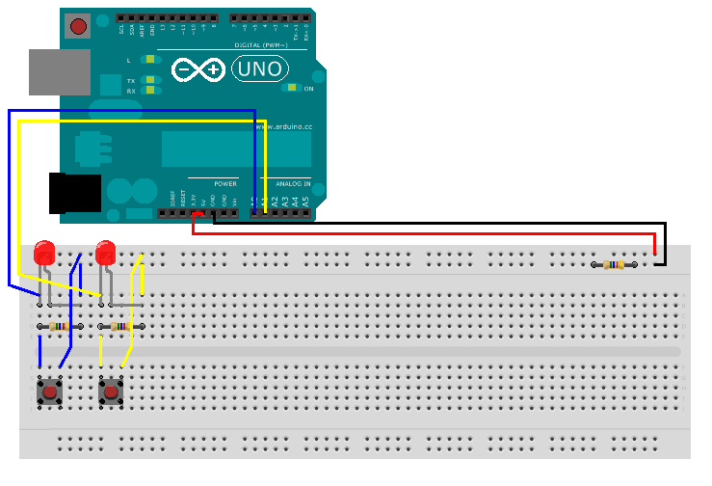

As shown in the image above, the second sensor pretty much follows the same layout of the first sensor.

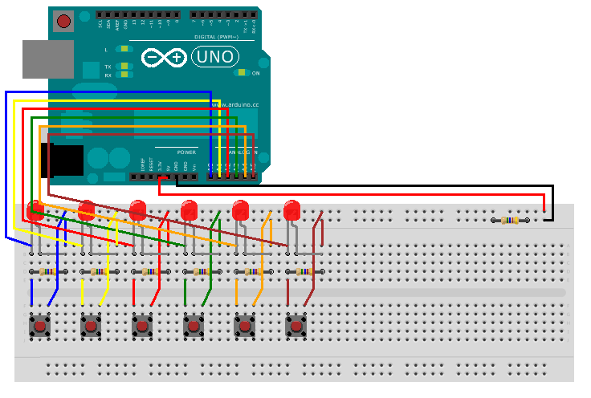

This should be the finished layout of the piano with 6 push switches in use. You should check that each sensor works by checking if the LED lights up.

**Connecting the speaker**

4

This step is pretty simple. With the speaker, connect one wire of the speaker into Digital Pin 8 and then connect the other speaker wire to the positive horizontal terminal to receive power.

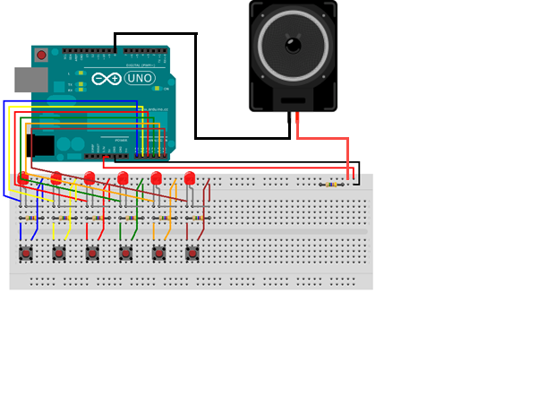

If you already haven’t, upload the code to the Arduino.

Now to test out your piano. Press a button to see if it makes a noise, if it does then you have working Arduino Piano.

**If it doesn’t play sound:**

* **Check that all connection are correct. A misconnection can make the Arduino not work.**
* **Check your code if there is a mistake.**

*

**Teacher Notes:**

**Things that students could do:**

* Allow students to construct one or more sensors by following an example finished sensor.
* Create another Arduino analogue piano using the same breadboard to allow more notes to be played.